Ensemble Tone Quality, Articulation and Rehearsal Techniques

Pennsylvania Music Educators Association
District 8 In-Service
October 14, 2019
Bucknell University
M. Gregory Martin, Clinician

I. How do I get “that sound?”
a. Encourage posture and their VERY BEST SOUND
b. Encourage them to “disappear” into the overall sound
of the band. (Richard Floyd – play so you can hear
the person 2 seats away from you.)
c. Insist on proper balance and blend (the difference is
just like baking a cake!)
d. Constantly remind and stay on them utilizing (Lip
Benders #2)
e. Work on this daily and throughout ALL rehearsals.
f. Reinforce (Lip Benders #10).

Pyramid of Sound (Blend AND Dynamics)

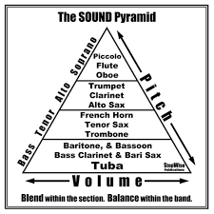

II. Articulation
a. Encourage the students to listen to one another for length
without initially identifying what length you want.
b. Have them identify who is longer and who is shorter
(Pyramid of Sound affects this).
c. Establish length from the beginning (Lip Benders #9).
d. In concert music, composers give us an amazing amount of
clues (not just the articulation markings)!

III. Rehearsal Techniques
a. Be organized, have a plan and put it on the board so the
students know the order and sequence.
b. Pacing – CRITICAL. Keep the rehearsal moving – time is so short
anyway so utilize it!
c. KNOW HOW YOU WANT THE PIECE TO SOUND!
d. When isolating or repeating sections, TELL them why, what,
and how when appropriate.
e. Macro – Micro – Macro
f. Record rehearsals – you are not superhuman and cannot
possibly hear everything!
g. Invite colleagues to come in and conduct your group so
you can LISTEN.

